**Aim:-** Hosting the website with Domain Registration Process.

**Theory:-**

Step 1: Visithttp://www.freenom.com/en/index.html?lang=en

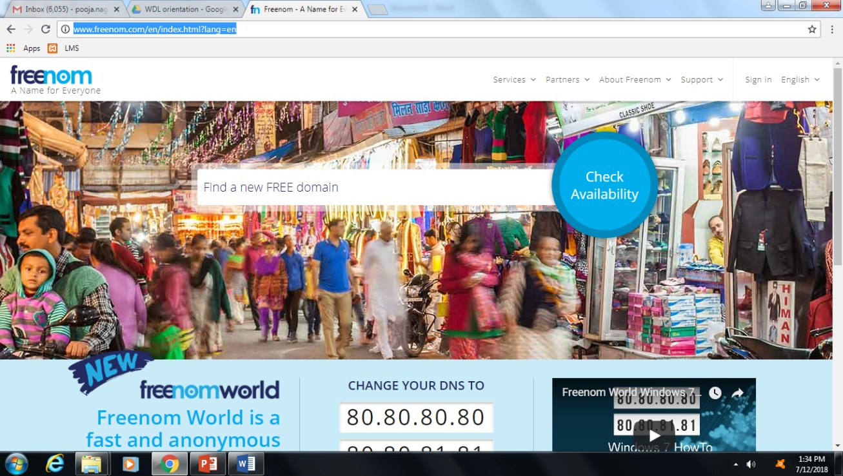

Step 2: Find A new Free Domain and check its availability

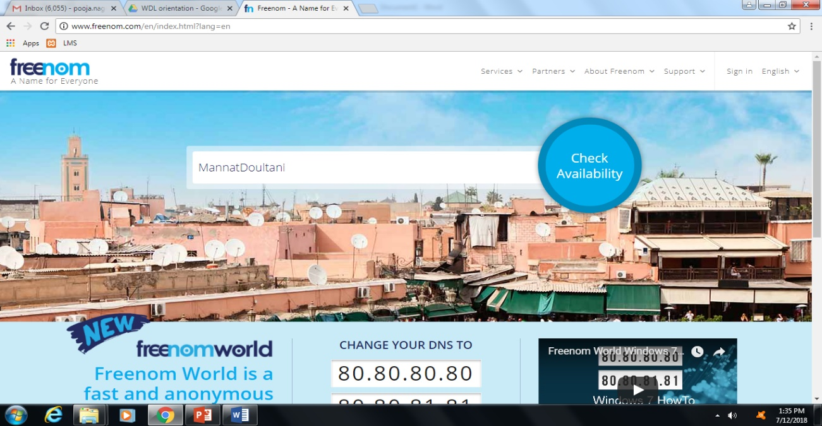

Step 3: once the subdomain Example(say MannatDoultani) is available select for the domain as shown in screen short. Go for .tk(Suggestable) and checkout

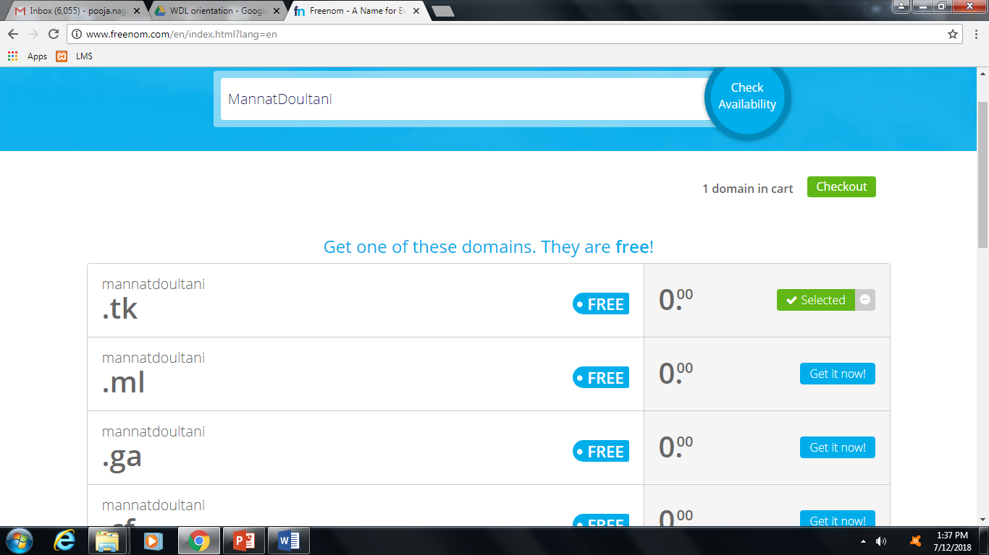

Step 4: Select the Time Period & click on Continue

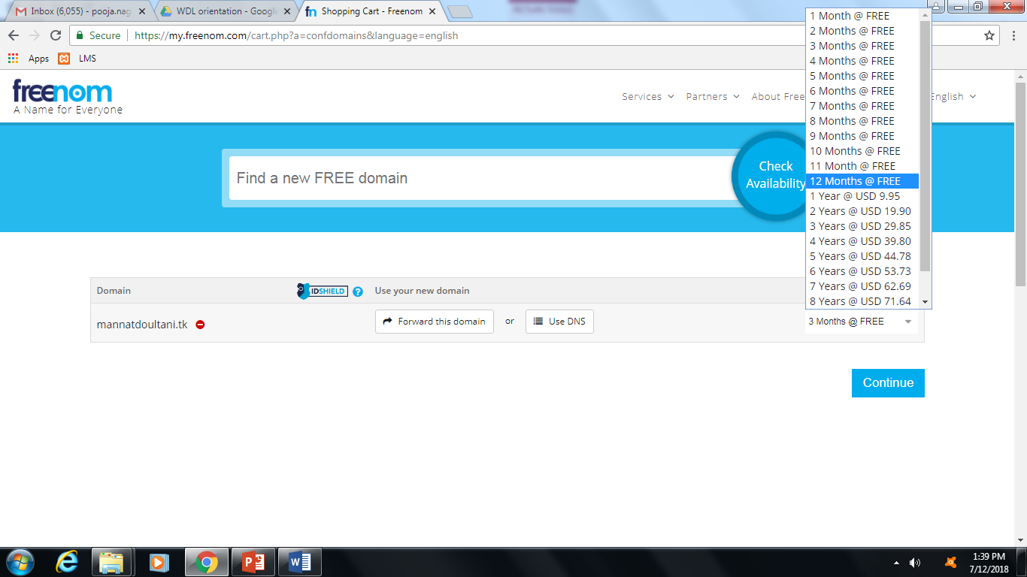

Step 5: Enter Your email and verify the same. You will get a verification link in mail inbox.

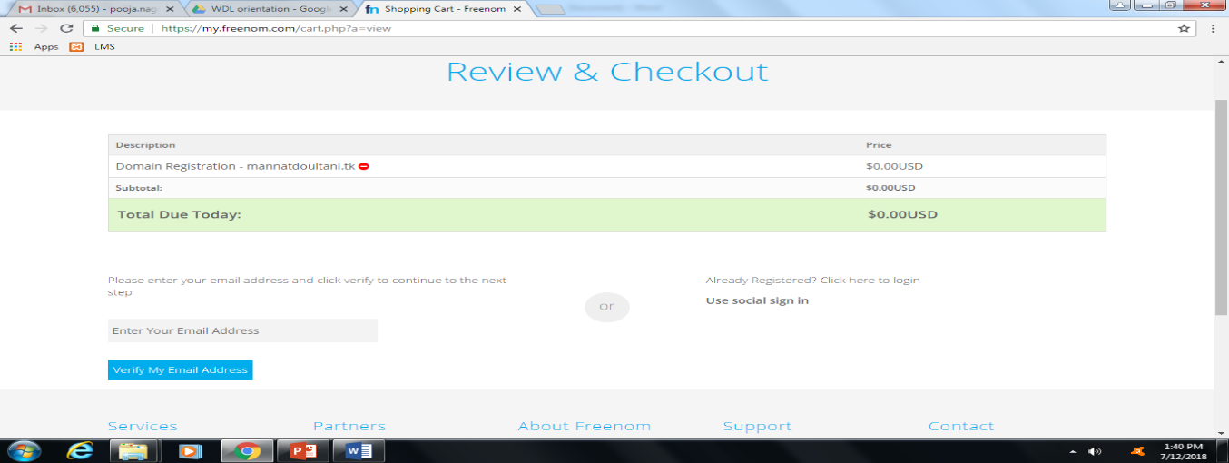

Step 6: Click on the verification link, you will get a profile page to be updated

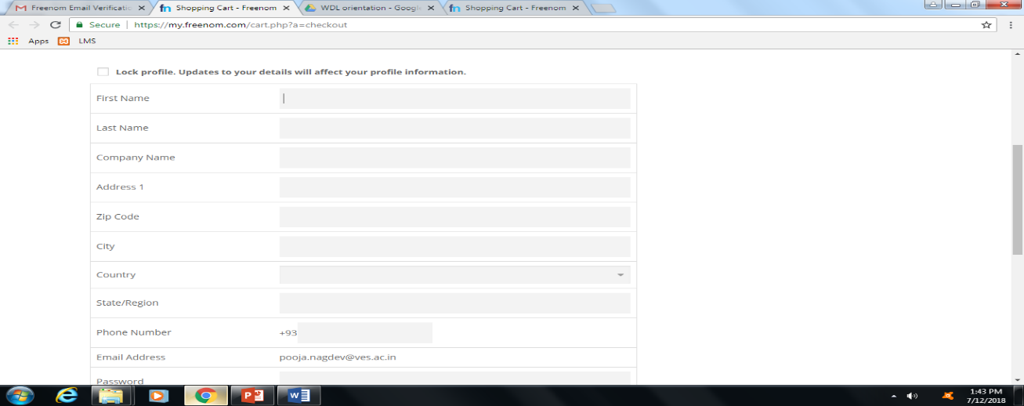

Step 7: once done with profile agree to terms and services and Confirm the Order

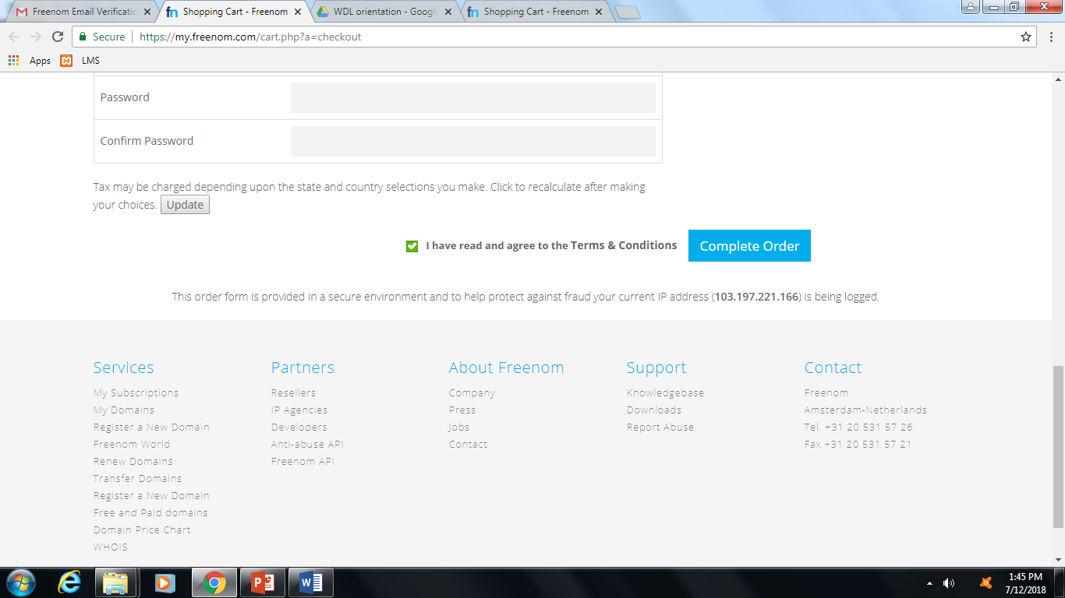

Step 8: At the end you will get your order number

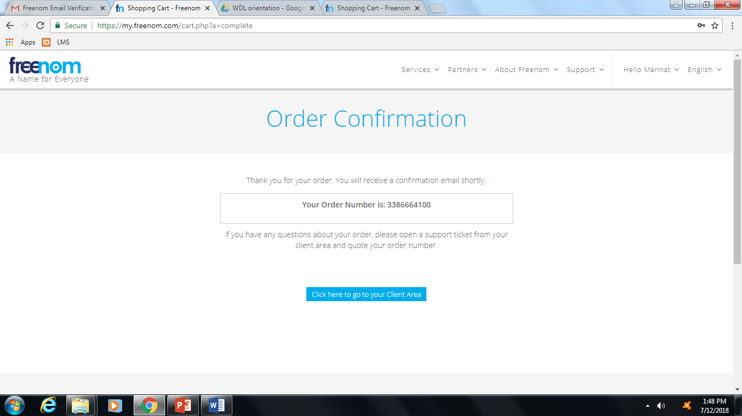

Thus Purchase of Domain Successfully done

WEB HOSTING

Step 1: Visit [www.000webhost.com](http://www.000webhost.com) & choose a Free plan



Step 2: Sign up and enter the domain name you purchased from freenom & click on Get free hosting

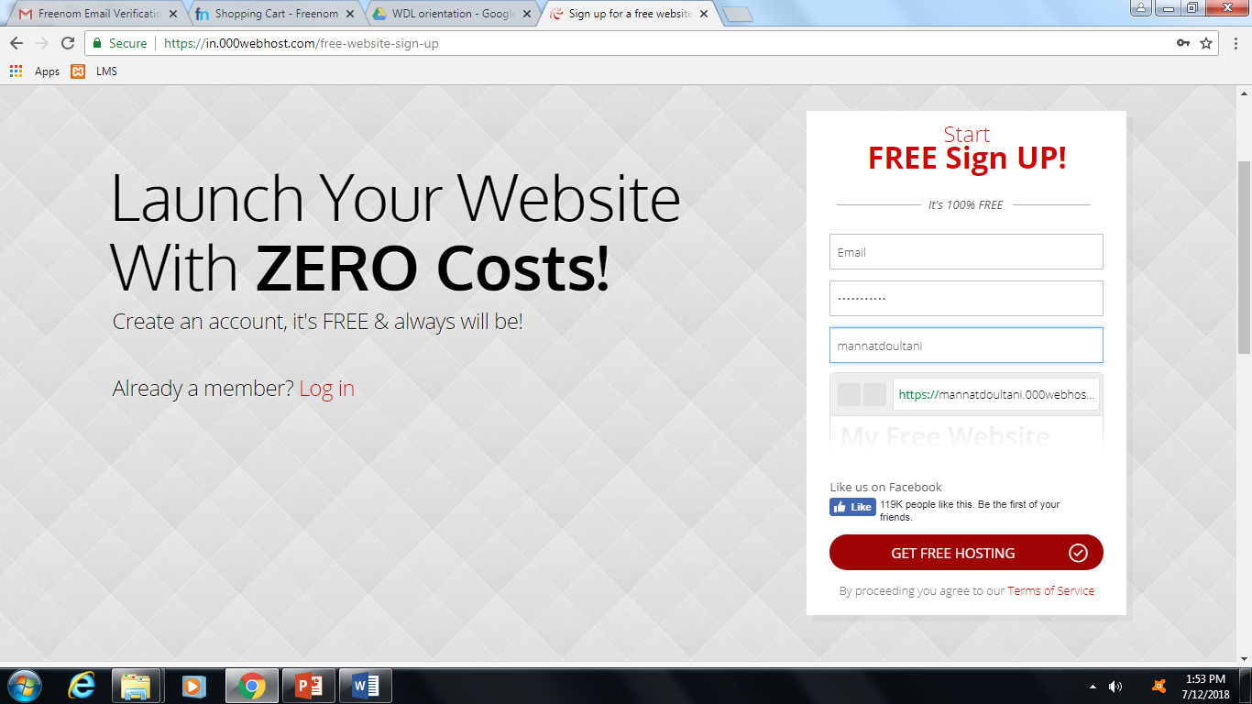

Step 3: An email confirmation will be sent on your registered mail id. Kindly verify and you will get the following screen. Click on “Manage Website XXXX”

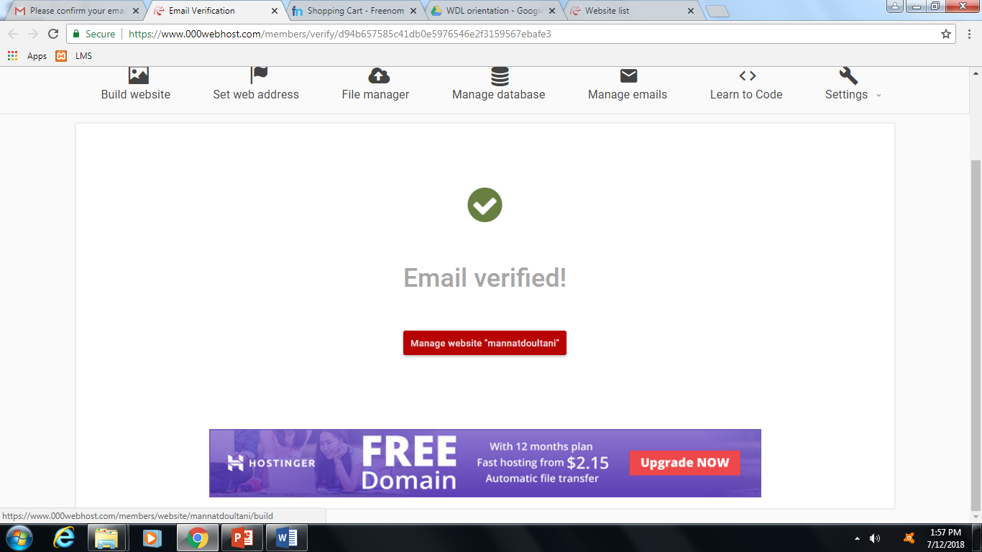

Step 4: After you click on Manage website you will get following 3 options for building your website

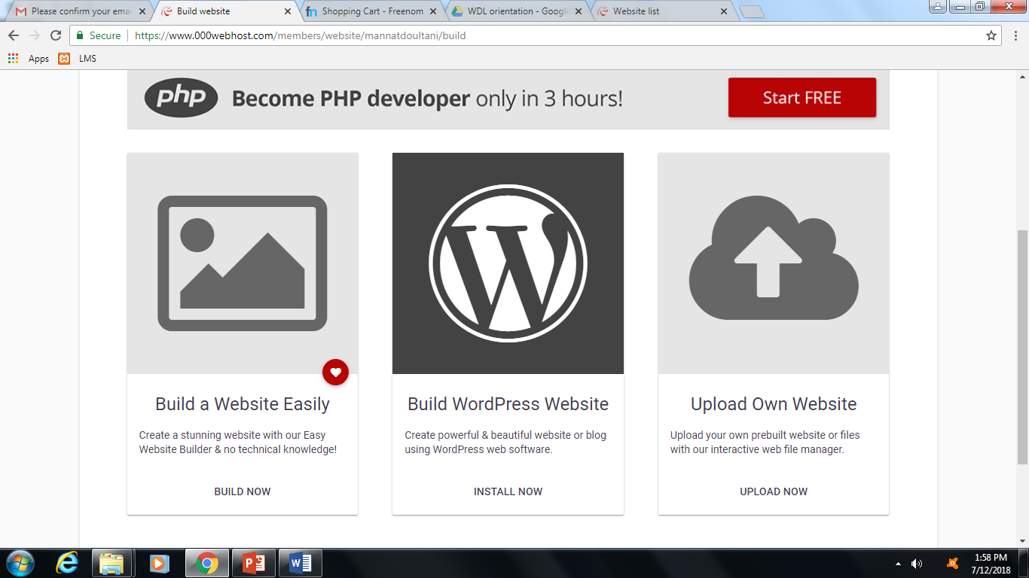

Step 5: Take Example of Uploading A html Page you have already created. So select on Upload Own Website. You will be directed to the following page

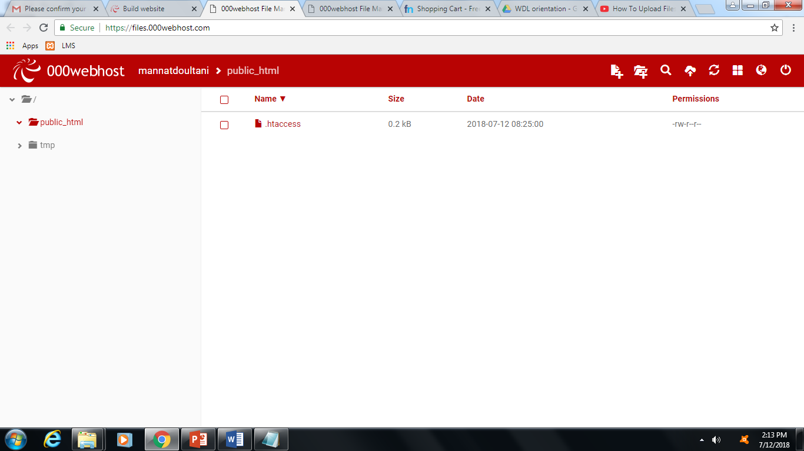

Step 6: Select Folder public_html and then select upload files icon on top right corner amongst the 8 icons given. You will get the following pop up message

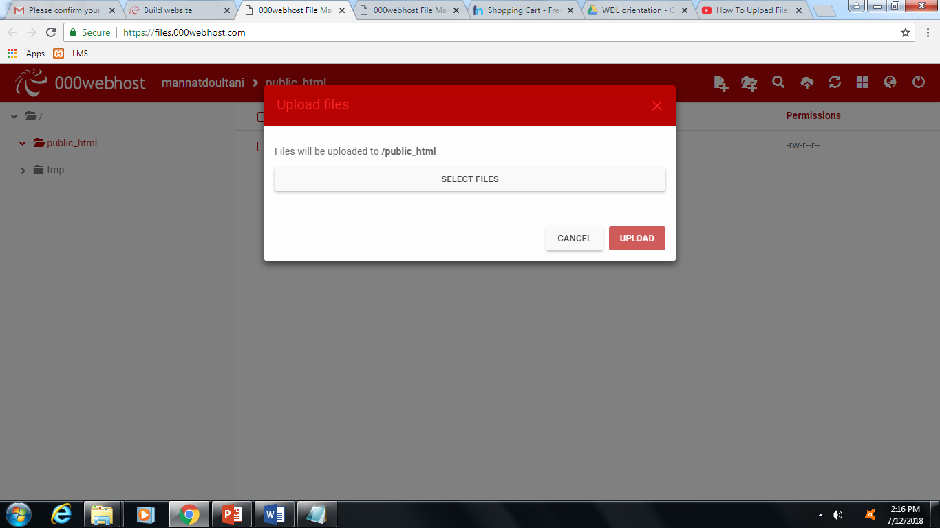

Step 7: Select File to be uploaded from your PC and Upload

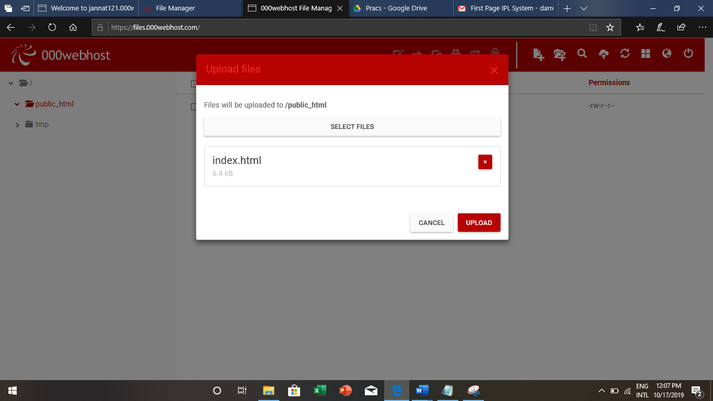

Step 8: it will be then shown in public_html.

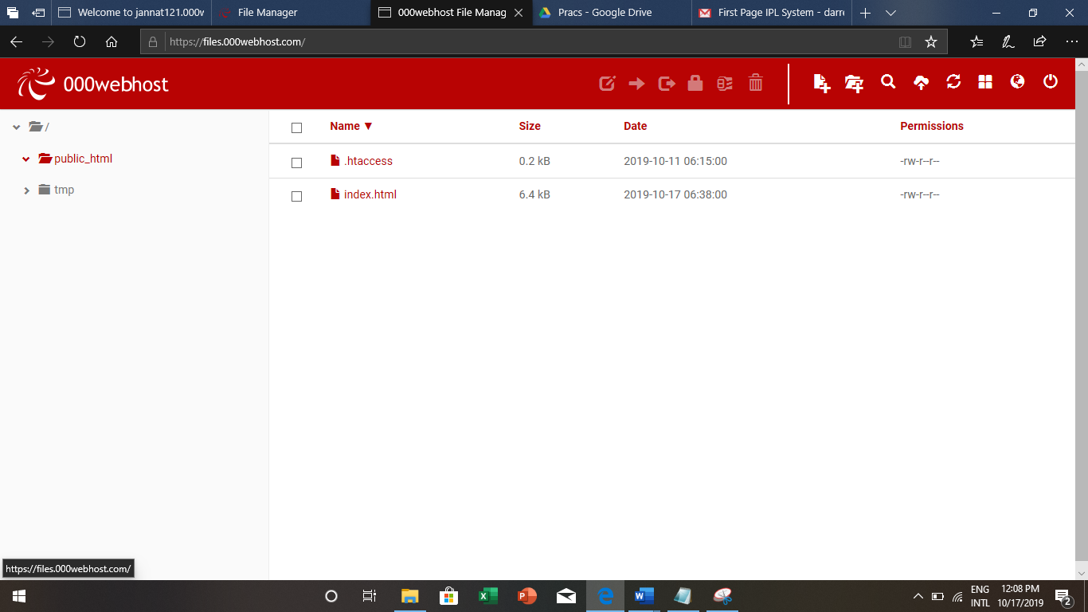

Step 9: once the files are uploaded go to the following page & click on Website link provide.

Note: Name your first file as index.html otherwise it will not display the website

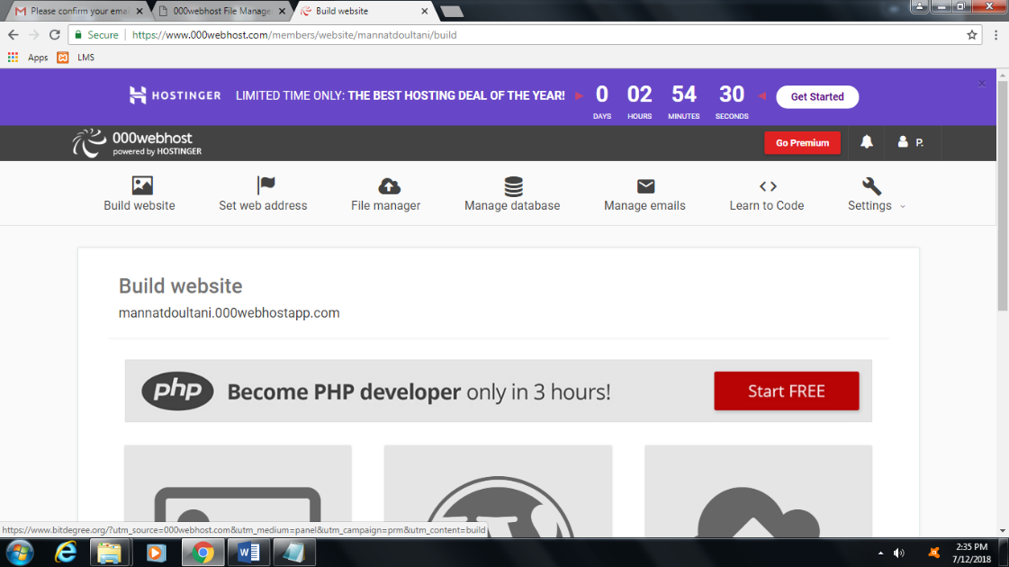

Step 10: website will appear under Build Website statement just click you will be directed to your web page.

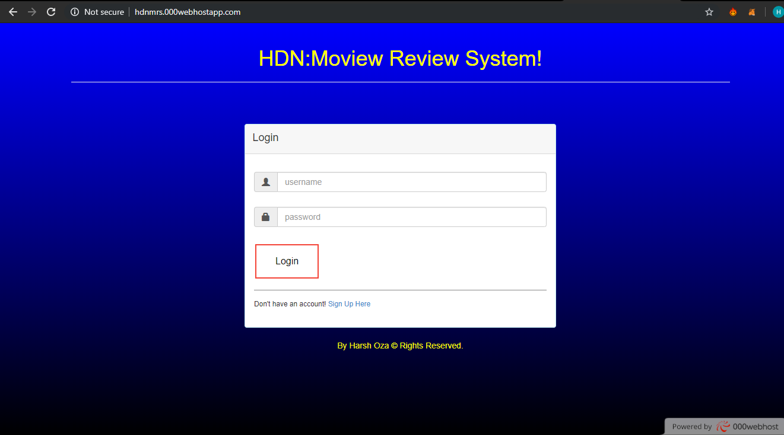



**CONCLUSION:** We hosted a web page with domain registration process. We visited

[www.000webhost.com](http://www.000webhost.com) and accordingly followed the steps to host the web page. Our web page was successfully hosted.We hosted hdnmrs.000webhostapp.com